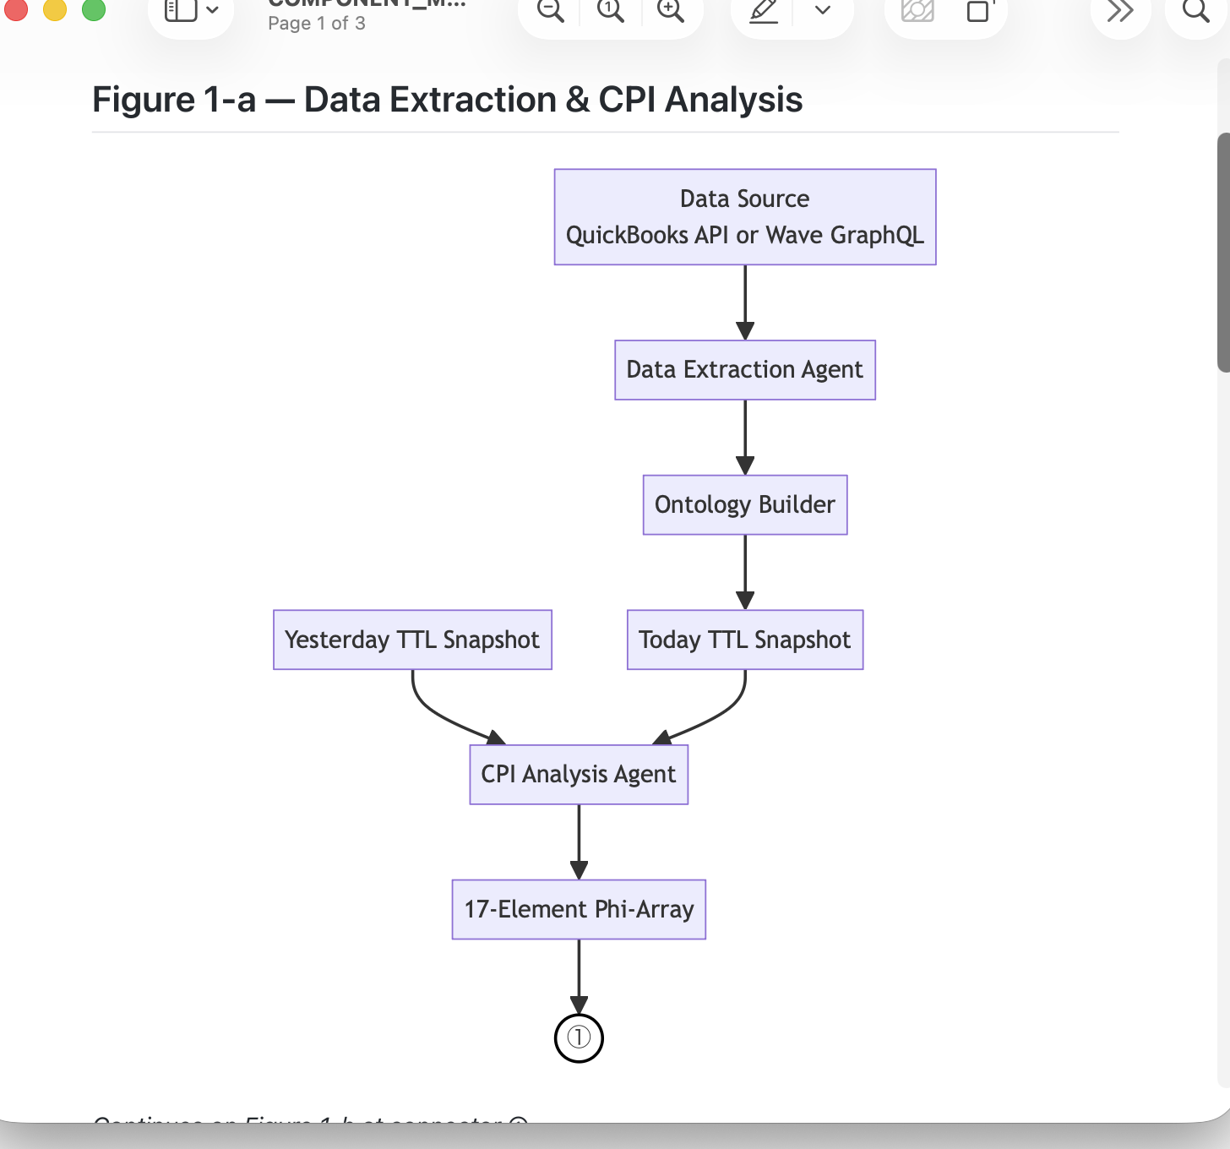
How to get this graphic onto a print page (here an .odt, to be transformed to .pdf):

- Open Cursor’s .md rendition with QL Markdown
- Export as .html
- Open .html with Chrome
- Take a screenshot, paste it onto the OpenOffice text page and crop to size

